ASR config server troubleshooting

C:\Program Files\Microsoft Azure Recovery Services Agent\Temp\CBEngineCurr.errlog is a good log to view the detailed status of replication. You’ll have to know the disk ID and search for it.
E:\Program Files (x86)\Microsoft Azure Site Recovery\home\svsystems\var also has some good logs

Can check processes are sending and receiving data from servers to azure using resource monitor:
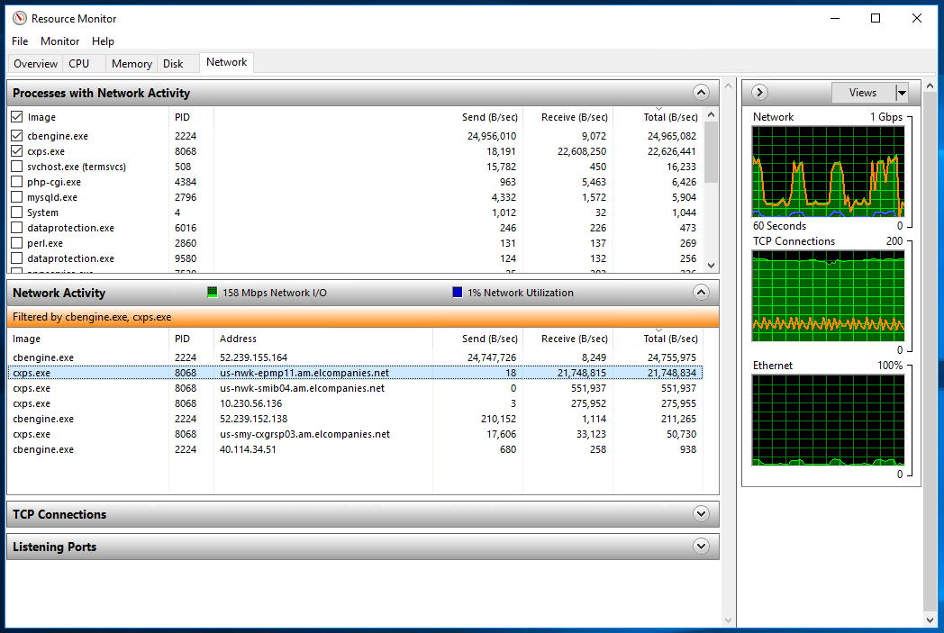

- Source Server fails to register with Configuration Server

